21.68: a) 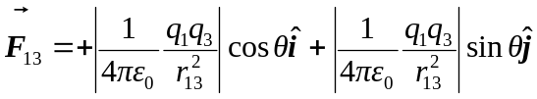
Similarly for the force from the other charge:
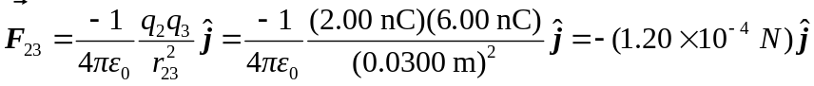
Therefore the two force components are:
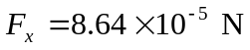
b) Thus, and the angle is 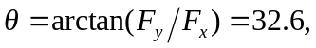below the x axis

